**FOR INDIVIDUALS**

**WE OFFER  
Door-to-door transport**Please do it as in this page by changing names: <https://www.montway.com/door-to-door-auto-transport>

**Open car transport**

Please do it as in this page by changing names: <https://www.montway.com/open-car-transport>

**Enclosed auto transport**

Please do it as in this page by changing names: <https://www.montway.com/enclosed-auto-transport>

**Motorcycle shipping**

Please do it as in this page by changing names: <https://www.montway.com/motorcycle-shipping>

Manabu qismini qo’shish shart emas: 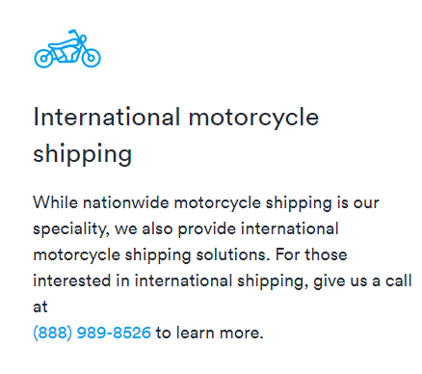

Uning o’rniga manabuni qo’ying: 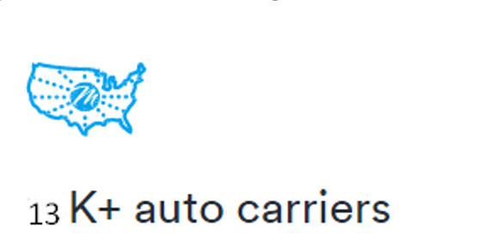

United Freeway Transportation has a huge network of haulers who are personally vetted auto shipping experts, ensuring your Motorcycle is transported by trusted members of the industry. These shipping companies will treat your motorcycle like their own.

**WE SERVE**

**Online car buyers**

Please do it as in this page by changing names: <https://www.montway.com/car-buyers-auto-transport>

**College students**

Please do it as in this page by changing names: <https://www.montway.com/students-auto-transport>

**Snowbirds**

Please do it as in this page by changing names: <https://www.montway.com/snowbirds-auto-transport>

**Car collectors**

Please do it as in this page by changing names: <https://www.montway.com/classic-cars-auto-transport>

**Car resellers**

Please do it as in this page by changing names: <https://www.montway.com/car-resellers-auto-transport>

**Military**

Please do it as in this page by changing names: https://www.montway.com/military-auto-transport